**Summary**

This document gives excerpts from the Approved Document B that gives guidance with respect to fire safety in dwellings and other houses and presents a few implications to the Cambond products. The main conclusion is that the size of the market Cambond may expect to be relevant depends strongly on the density and rating of its products.

**Implications**

* Gypsum plasterboard, calcium silicate board and fibre-cement board are classified as standard substrates that do not need fire-resistance testing. Cambond is at a disadvantage because they would need to perform these tests for different products and intended applications.
* The required fire resistance classification in buildings depends on the purpose of the building (e.g. less stringent requirements for dwelling houses, more stringent for (large) apartment buildings and more stringent still for warehouses, etc.) The size of the market and potential applications will change depending on what fire resistance rating the cambond products will have.
* The rooms and circulation spaces within a dwelling should comply with at most C-s3, d2 certification. I suspect that this is below the certification that Cambond products would obtain, so from the “complies with regulations” value proposition angle, Cambond products would not be relevant to small dwellings.
* The exception are compartmentalisation structures (e.g. between semi-detached or terraced apartments) and should comply with the B3/B4 tables, which in general would mean RE(I) 30/60 rating. Would this be too small of a market to target?

**Actions**

* Clarify what test specifications these products get, so that we can narrow down the market niche.
* Narrow down whether the boards are applicable to R (load-bearing, probably not), E (integrity, possibly) or I (insulation, most likely) performance.

**Main resources:**

* Approved Document B. Approved documents cover directions on fulfilling the requirements of building regulations in common scenarios. Part B covers fire safety within and around buildings and comes in two volumes: [Dwellings](https://assets.publishing.service.gov.uk/government/uploads/system/uploads/attachment_data/file/937931/ADB_Vol1_Dwellings_2019_edition_inc_2020_amendments.pdf) and [other buildings](https://assets.publishing.service.gov.uk/government/uploads/system/uploads/attachment_data/file/937932/ADB_Vol2_Buildings_other_than_dwellings_2019_edition_inc_2020_amendments.pdf). The main standards are BS EN 13501-1 to 4.
* BS EN 13501-1 to 4: Fire classification of construction products and building elements, is the classification for some products to receive a CE marking signifying that a product satisfies the relevant regulations. Unfortunately, [it is not accessible for free from the british standards institution](https://shop.bsigroup.com/ProductDetail?pid=000000000030348263), but a lot of the classification is explained in the Approved Document B. These cover (roughly):
  + Reaction to fire (EN 13501-1)
  + Resistance to fire (EN 13501-2; REI xx signifies that the material is resistance for at least xx min with respect to R/E/I type of resistance. ).
  + 13501-3 (products and elements used in building service installations: fire resisting ducts and fire dampers)
  + 13501-4 (components of smoke control systems)

**EXCERPTS FROM APPROVED DOCUMENT B TO GET AN IDEA OF HOW CLASSIFICATION WORKS AND WHAT CLASSES THERE ARE**

Appendix B (Performance of materials, products and structures) provides a lot of information on the classification. Some relevant excerpts:

B6 Reaction to fire relates to the degree to which a product will contribute, by its own decomposition, to a fire under specified conditions. Products, other than floorings, are classified as A1, A2, B, C, D, E or F (with class A1 being the highest performance and F being the lowest) in accordance with BS EN 13501-1. (...) Materials covered by the Classification Without Further Testing (CWFT) process can be found by accessing the European Commission’s website https://eur-lex.europa.eu/.

B7 The classes of reaction to fire performance of A2, B, C, D and E are accompanied by additional classifications related to the production of smoke (s1, s2, s3), with s1 indicating the lowest production, and/or flaming droplets/particles (d0, d1, d2), with d0 indicating the lowest production. (...)

B8 To reduce the testing burden on manufacturers, BS EN 13238 defines a number of standard substrates that produce test results representative of different end use applications. (...)

B9 Standard substrates include **gypsum plasterboard** (BS EN 520) with a density of 700+/-100kg/m3 , **calcium silicate board** (BS EN 14306) 870+/-50kg/m3 and **fibre-cement board** 1800+/-200kg/m3 . NOTE: Standard calcium silicate board is not representative of gypsum plasterboard end use (due to the paper layer), but would be representative of most gypsum plasters (with densities of more than 650kg/m3 ). NOTE: Classifications based on tests using a plasterboard substrate

**Some more information on classification and tests**

**BS 476**: Fire tests on building materials and structures. Mentioned (in Table B1, next page) tests:

BS 476-6 Method of test for fire propagation for products [1989 + A1 2009]

BS 476-7 Method of test to determine the classification of the surface spread of flame of products [1997]

BS 476-11 Method for assessing the heat emission from building materials [1982]

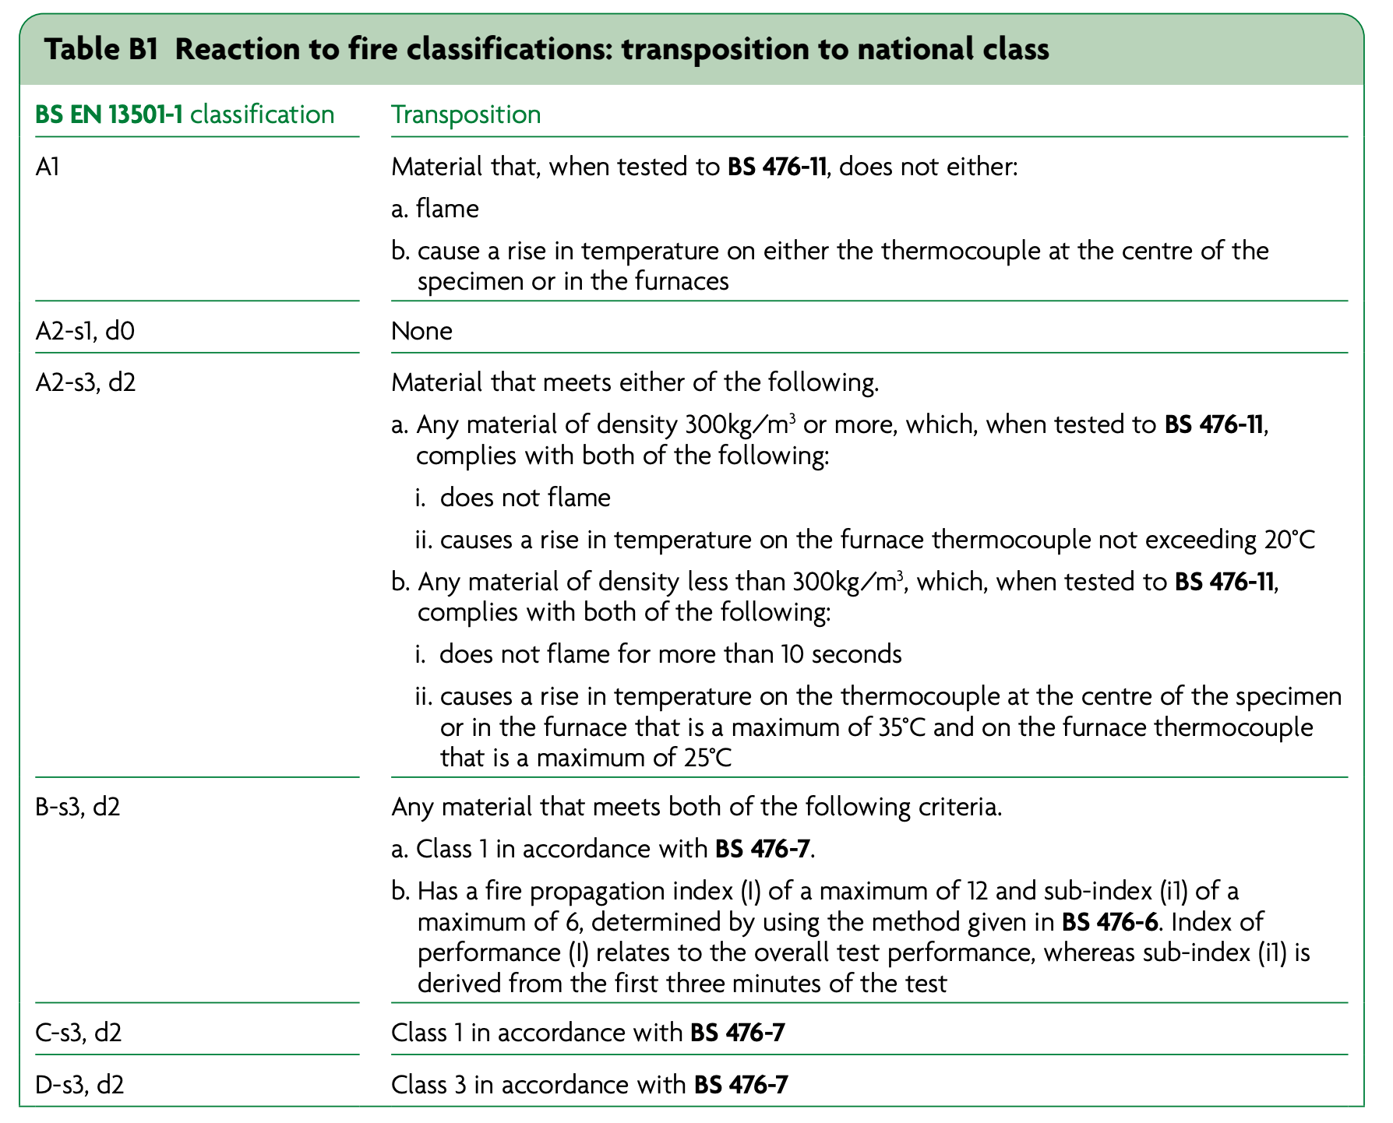

B19 Common to all of the provisions of Part B of the Building Regulations is the property of fire resistance. Fire resistance is a measure of one or more of the following.

a. Resistance to collapse (loadbearing capacity), which applies to loadbearing elements only, denoted R in the European classification of the resistance to fire performance.  
 b. Resistance to fire penetration (integrity), denoted E in the European classification of the resistance to fire performance.  
 c. Resistance to the transfer of excessive heat (insulation), denoted I in the European classification of the resistance to fire performance.

B23 Fire resistance is measured in minutes. This relates to time elapsed in a standard test and should not be confused with real time.

**Fire resistance standards for possible applications of CamBond boards**

A loong list covered in Appendix B: B25/Table B3 & related. mostly either R/E/I 30 or 60 if divided by elements of structure (roofs, walls, etc); or 30+ depending on height and purpose.